Lab Scenario:
You are a GRC analyst implementing a Policy Management process for a company preparing for ISO 27001 / SOC 2.
You will:
- Build a policy register
- Assign owners and stakeholders
- Define review cycles
- Perform and document a policy review
- Show status and traceability
Policies you’ll use:
- Information Security Policy
- Access Control Policy
- Acceptable Use Policy
This sounds real to hiring managers.

1. Create a policy register in Eramba CE
Step 1.1: Go to the policy module
- Log in to Eramba CE.
- Navigate to something like: Governance → Policy Management (or Documentation/Policies depending on version).
You should see an empty or existing list of policies.
Step 1.2: Add three core policies
For each policy, click Add and fill:
Policy 1 – Information Security Policy
- Title: Information Security Policy
- Description:
Defines the organization’s overall approach to information security, roles, responsibilities, and governance.
- Owner: CISO / Security Manager (or a test user)
- Status: Active
Policy 2 – Access Control Policy
- Title: Access Control Policy
- Description:
Defines how access is granted, reviewed, and revoked for systems and data.
- Owner: IT Manager / IAM Lead
- Status: Active
Policy 3 – Acceptable Use Policy
- Title: Acceptable Use Policy
- Description:
Defines acceptable and unacceptable use of company systems and data.
- Owner: HR / Security
- Status: Active
What this shows to hiring managers: You understand a policy register and basic ownership.
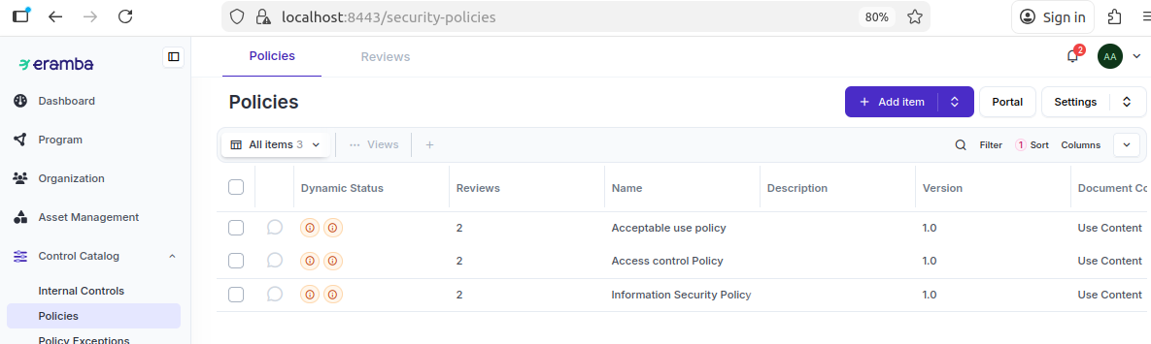

Add Governance Metadata
add metadata directly into the Description field.
For each policy, append:
Scope: All employees, contractors, and third parties.
Audience: All staff with access to company systems.
Review Frequency: Annual
Maturity: Initial / Repeatable / Defined (choose one)
Why this matters: You demonstrate understanding of policy governance, even without custom fields.
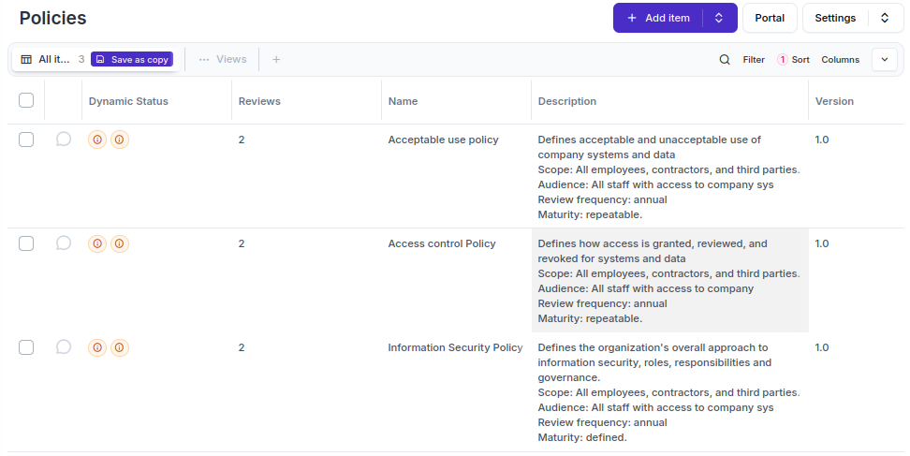

Perform a Policy Review (Hands-On Evidence)
Perform a review on “Information Security Policy”
So as seen in screen shot below the system automatically created two policy review records for information security policy.
One for planned date and actual date March 3, 2026 and other one for next review date March 9, 2026.
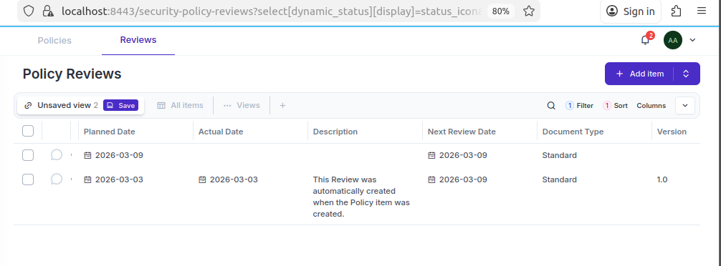
Scenario 1 – you want to change the document today March 3, and don’t want to wait until March 9.
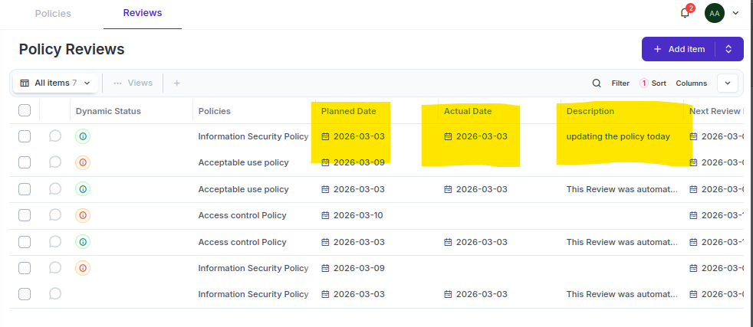
As you can see the policy version updated to 1.1
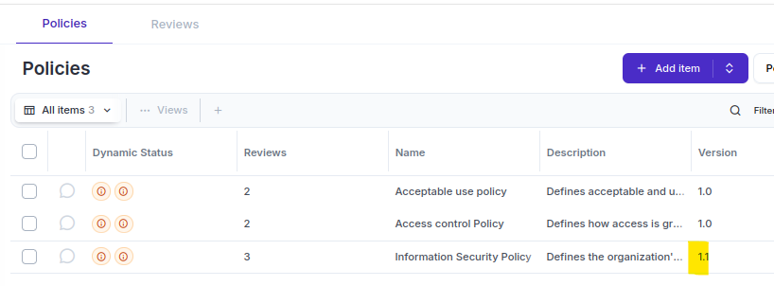
Document view
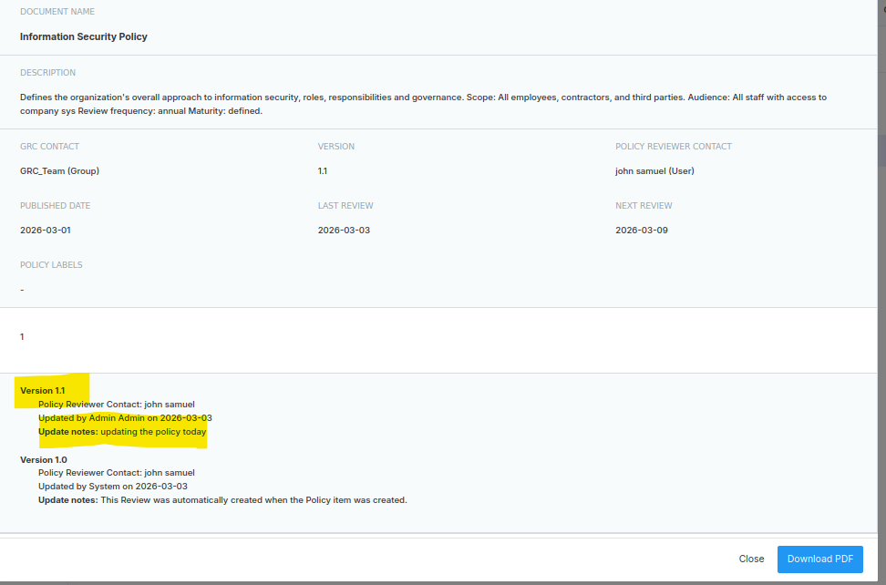
Scenario 2 –you want to change the planned review date from Mar 9 to Mar 6
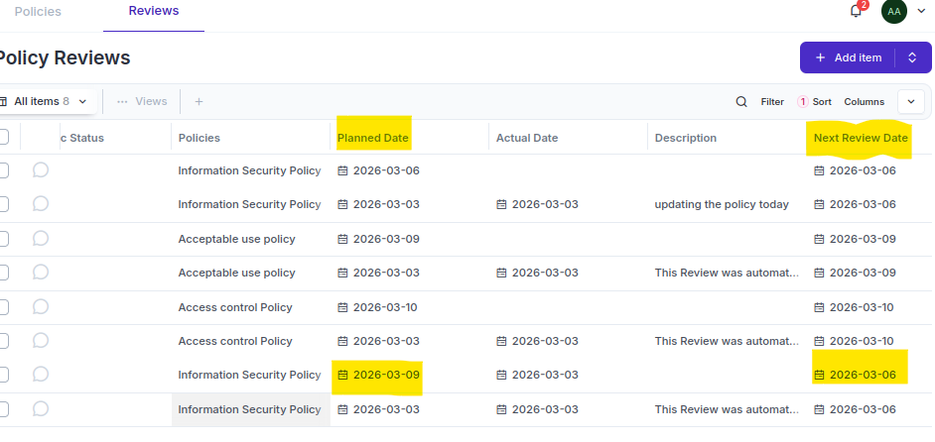
Scenario 3 – you don’t want to review the policy anymore
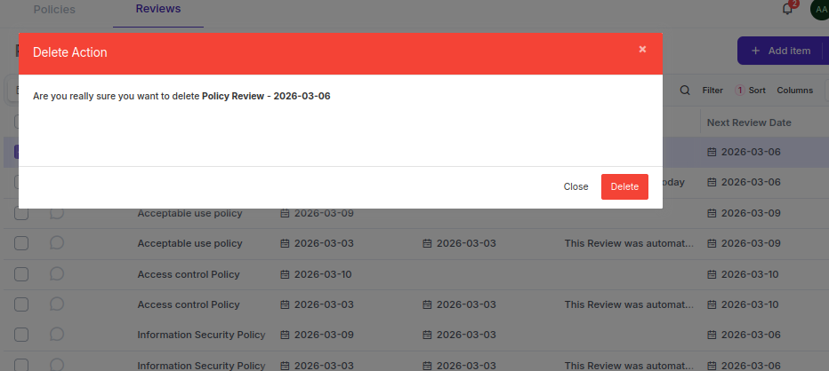
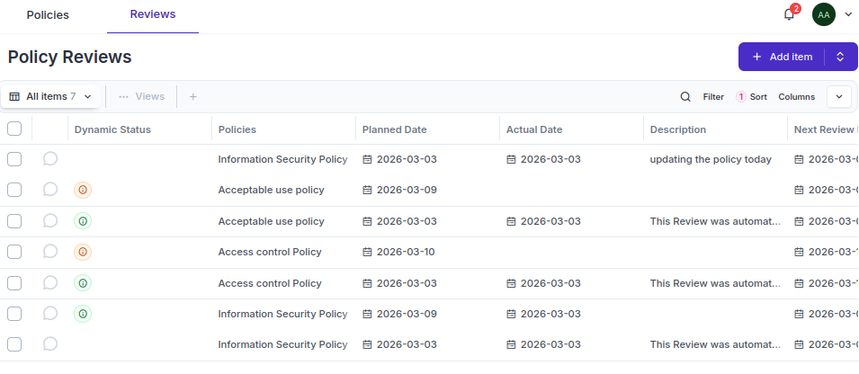

Why reviews are so important in Eramba?
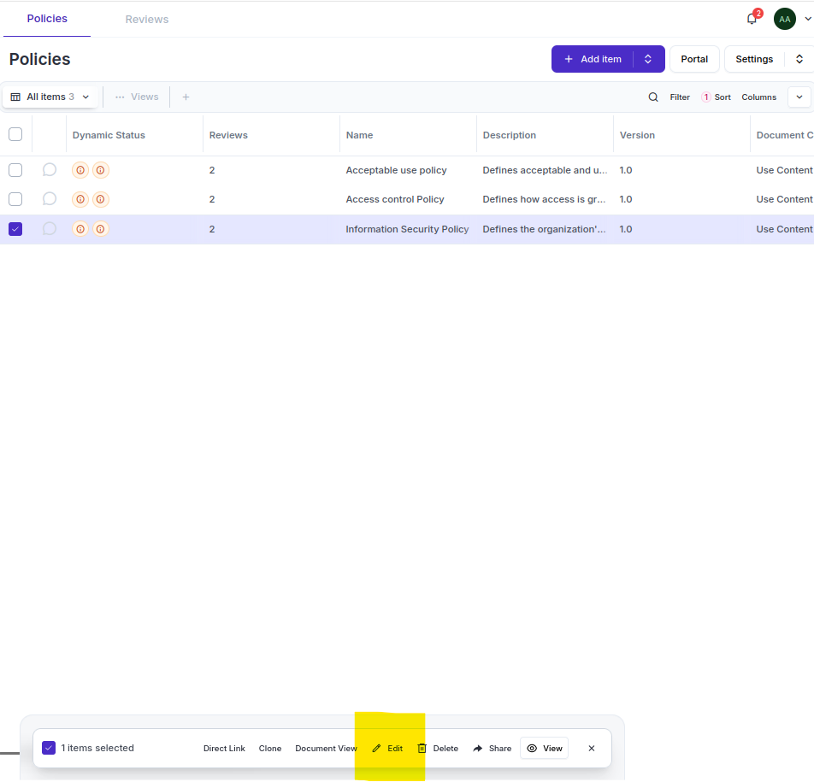
Review date is greyed out as seen below, and you cannot change content of the policy from policy module. It can only be done via review module.
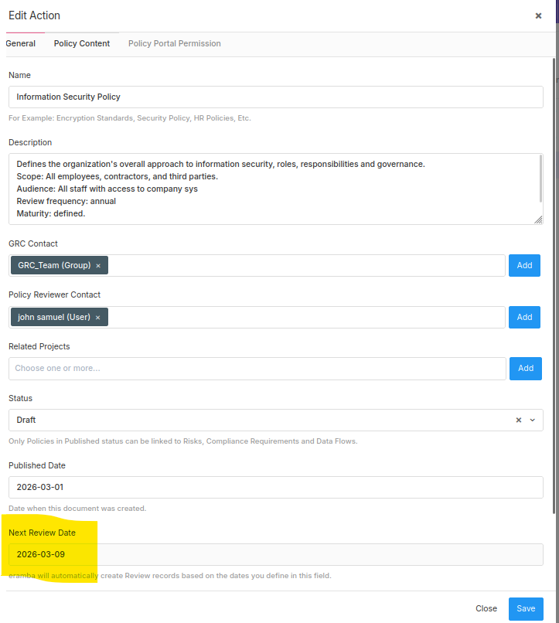
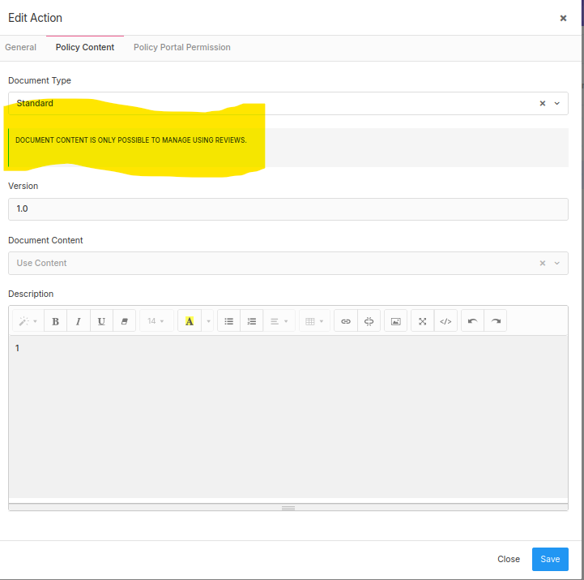

Export the Policy Register (Audit Evidence)
Document View is designed for:
- Exporting a single policy
- Getting a nicely formatted PDF
- Sharing a policy with staff or auditors
- Printing or publishing the policy

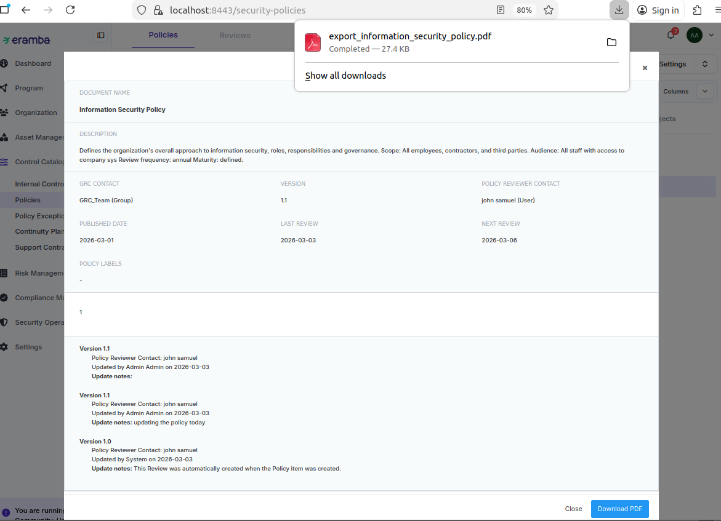

Use status to show policy lifecycle
Policy statuses in eramba are mainly draft and polished, though other statuses of the policy are tracked via dynamic status field.
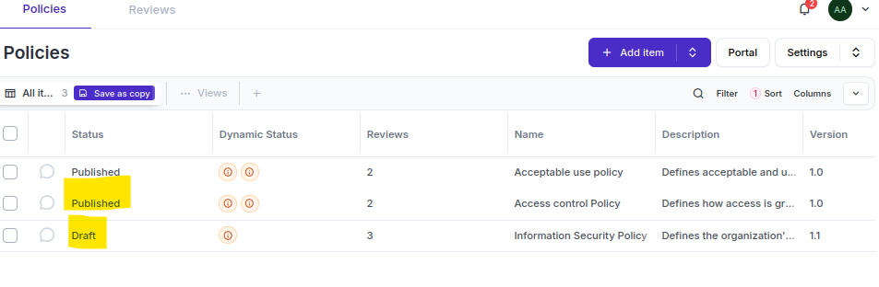

Policy Review statuses in Eramba are as following:
Planned – often reflected as deadline approaching under dynamic status.
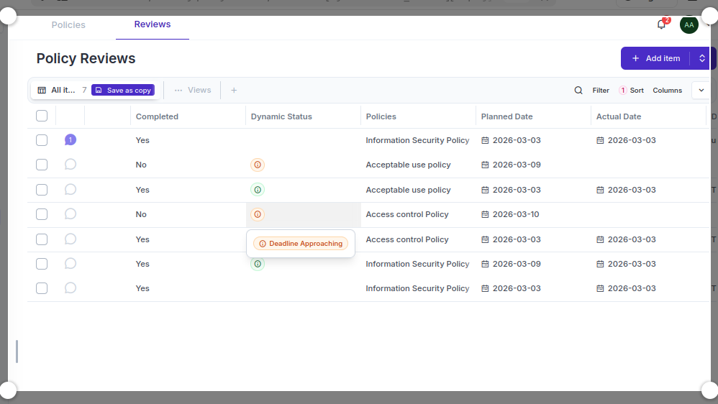
Completed – a completed view record.
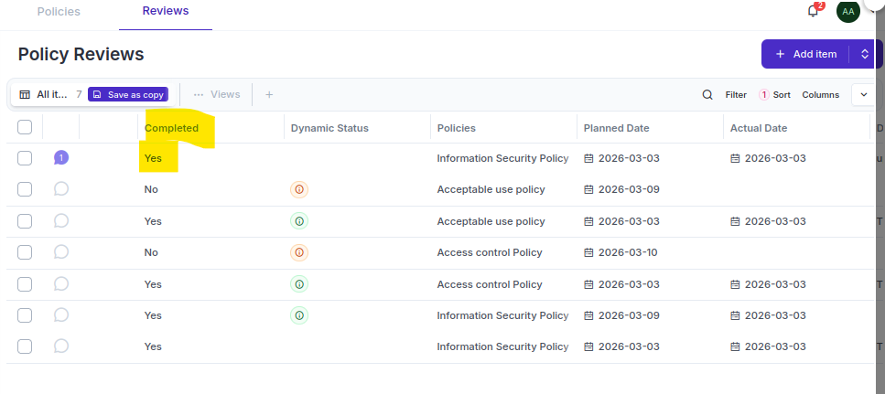
Current – the last completed record based on actual date.
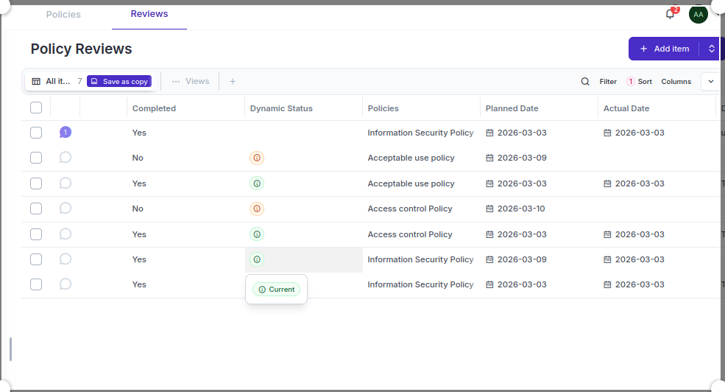

Create Views/Filters (CE-compatible)
- You demonstrate the ability to create operational views used by GRC teams and auditors.

Policies with expired reviews
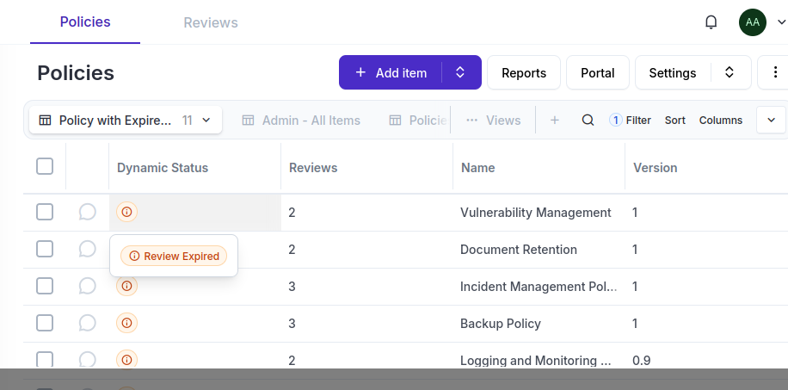

7. Simulate a “Policy Portal” Using Filters
Shows creativity and understanding of how GRC tools support end-users.
Policy portal is to show a consolidated view of all existing policies at one place.
